# Viewing of web application

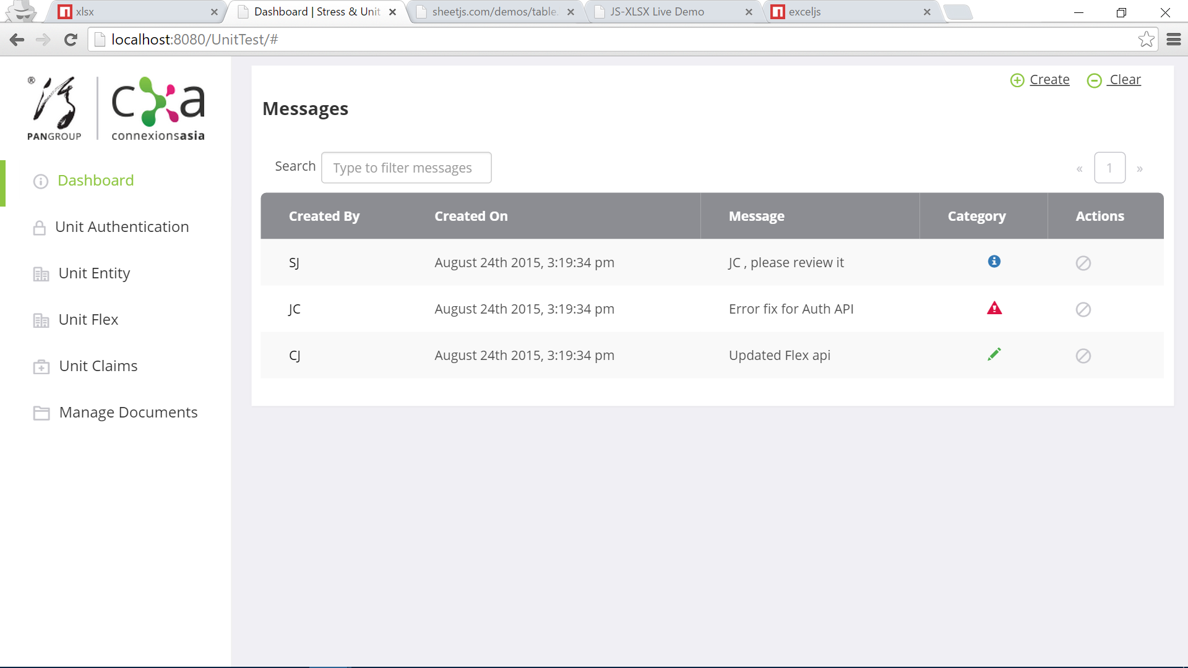

Dashboard Page

Dashboard page consist of these functions:

* View messages created by user or System generated messages when test failure rate is greater than 30%. Options on the Actions columns which are view details and remove messages, the
  1. View Details - Allows you to view a detailed side by side comparison between the current test and previous test.
  2. Remove Message - Allows you to remove only the selected message.
* Search to filter messages – Filter messages by name.
* Create messages - Create messages for others to view.
* Clear all messages - Clear All messages or searched messages.

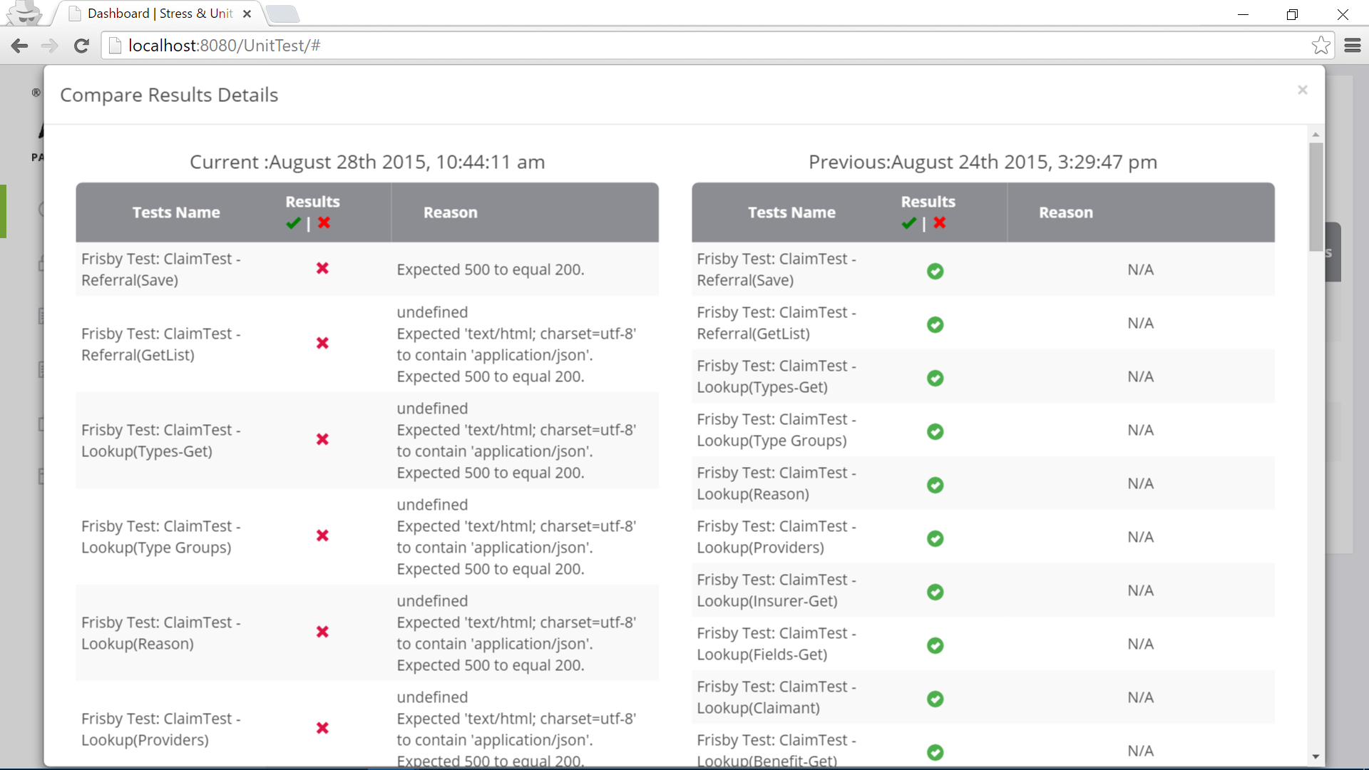

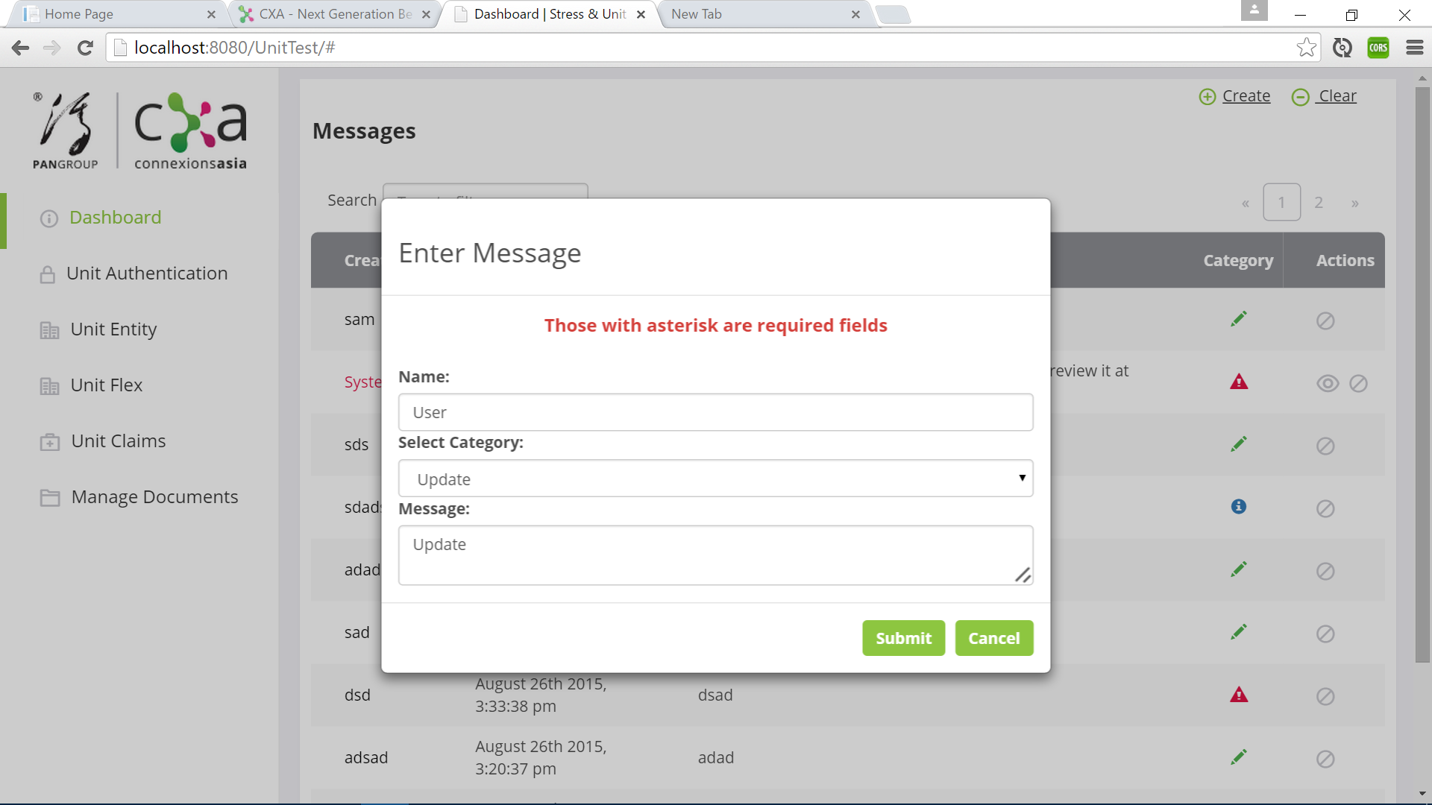

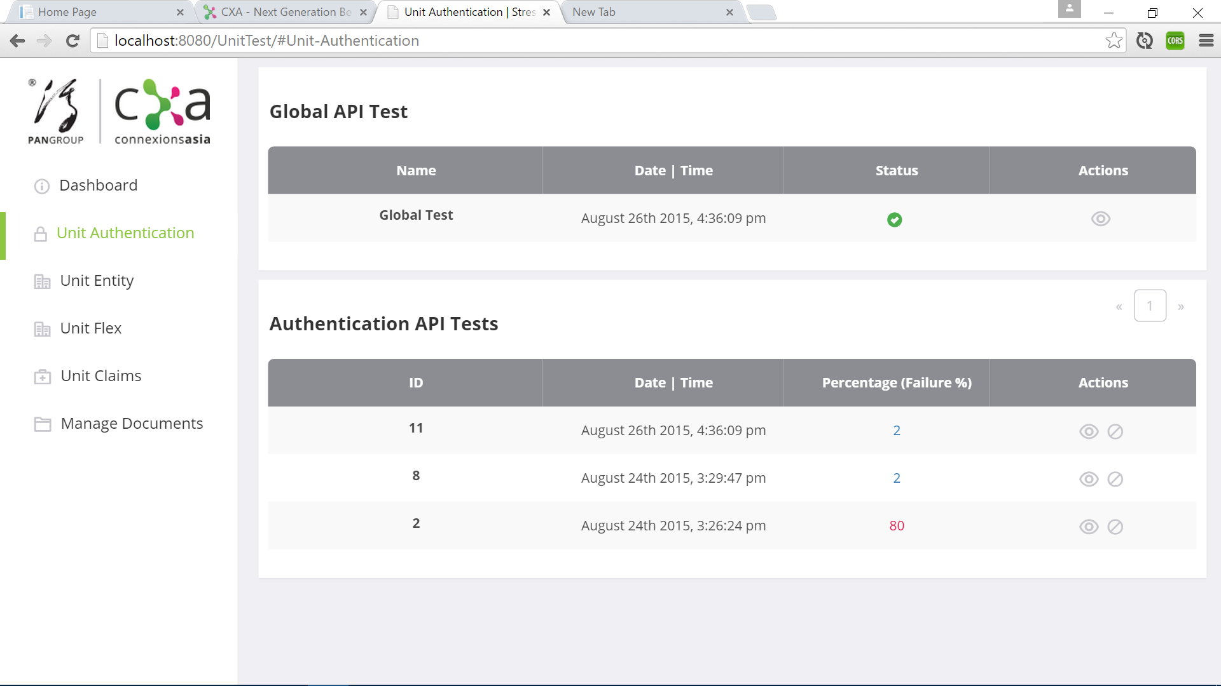

Unit Test Pages(Sub Page Unit Auth, Enity, Flex, Claims)

Unit Test pages consist of these functions:

* View API Test results after running the Frisby.js tests. Options on the Actions columns which are view details and remove test result.
  1. Global Test - Allows you to view details of global test which is the login details and sessionToken.
  2. Auth, Entity, Flex or Claims - Allows you view details for only the selected test type.

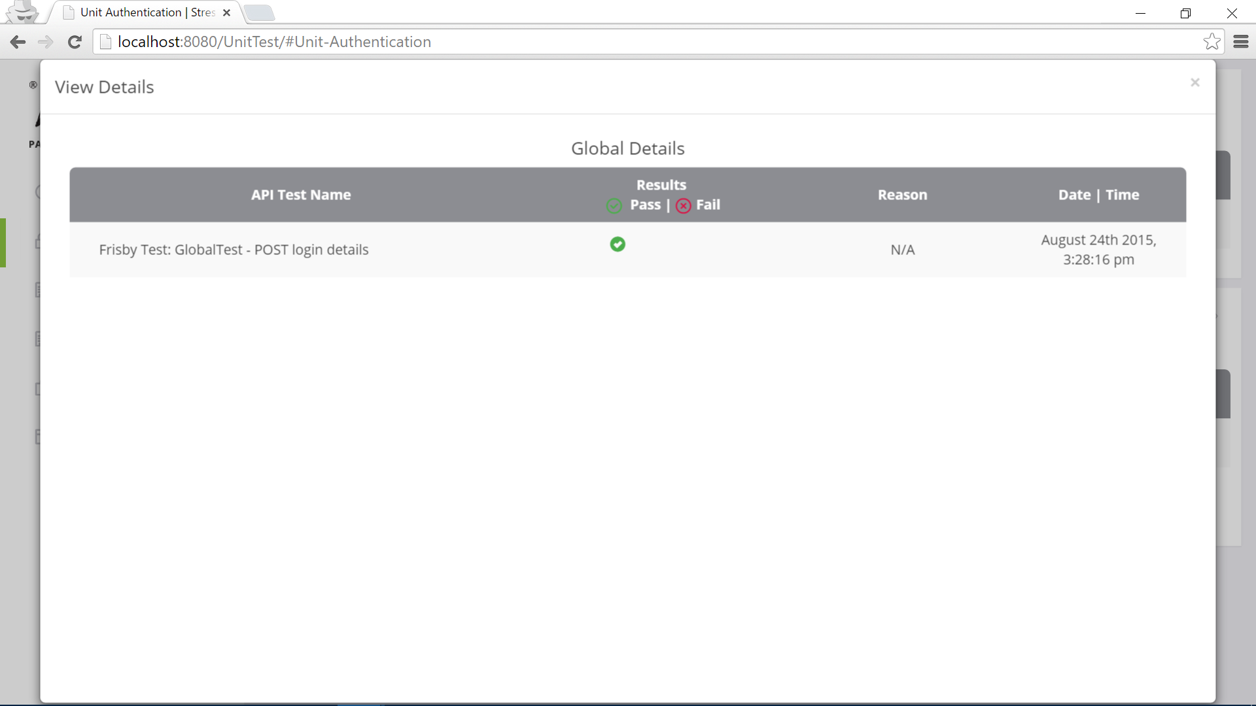

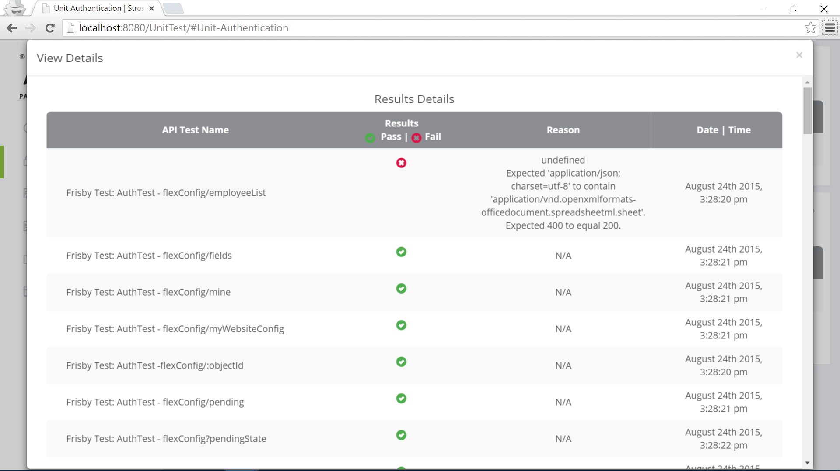

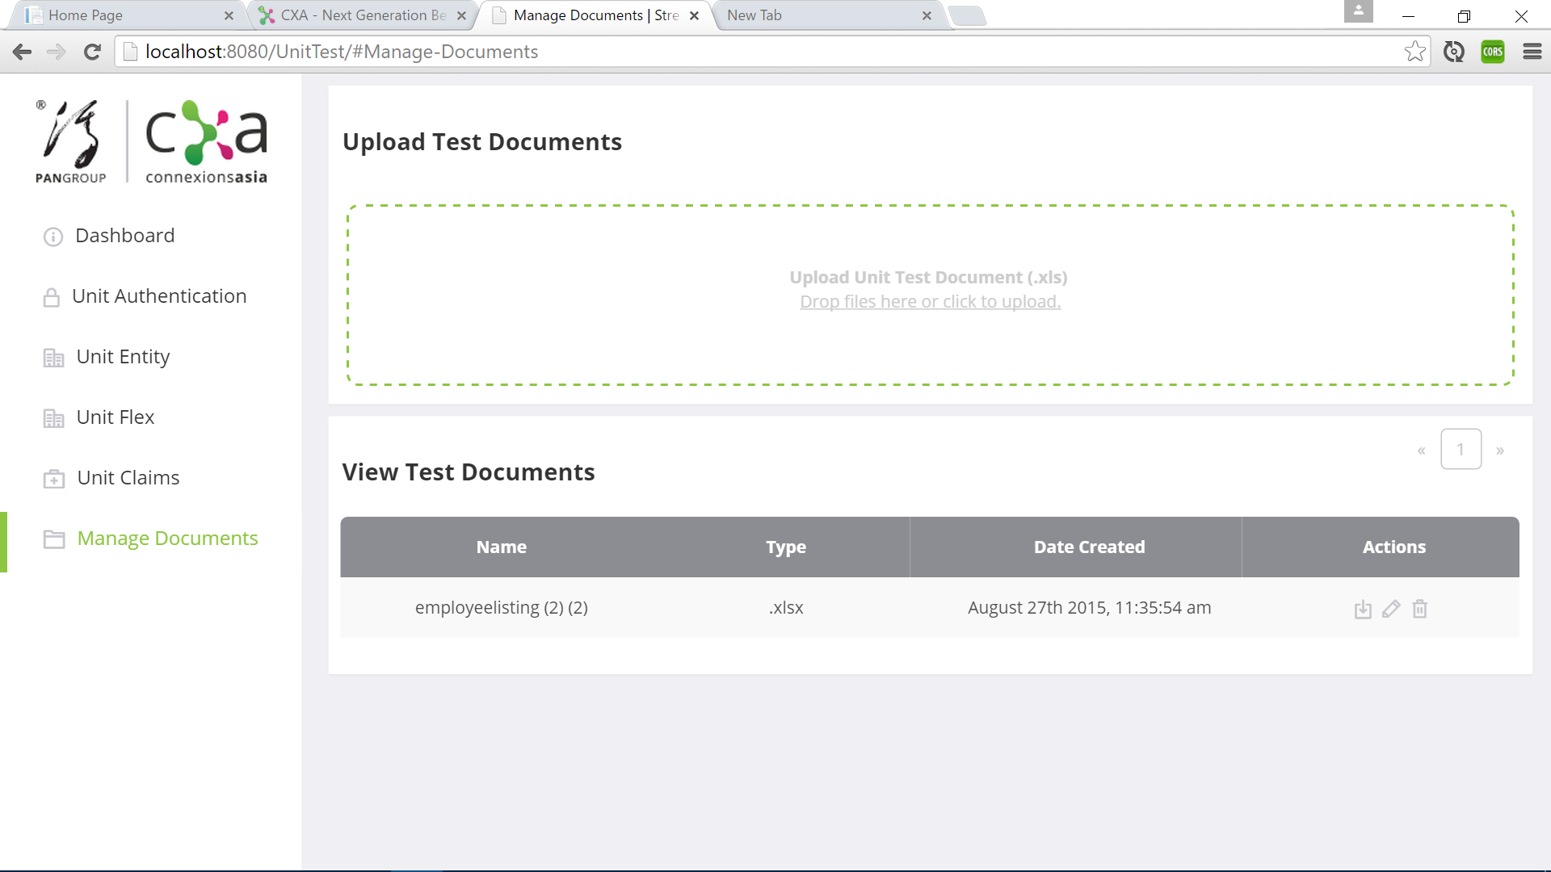

Upload test documents page

Manage Documents page consist of these functions:

* Upload generated RAML to excel file for documenting/updating the status of API tested .Options on the Actions columns which are download, update and delete document.
  1. Download - View excel file that users upload.
  2. Update – Upload to replace existing excel file with the edited.
  3. Delete – Delete excel file.
* Upload – Upload created excel file for others to view or edit.

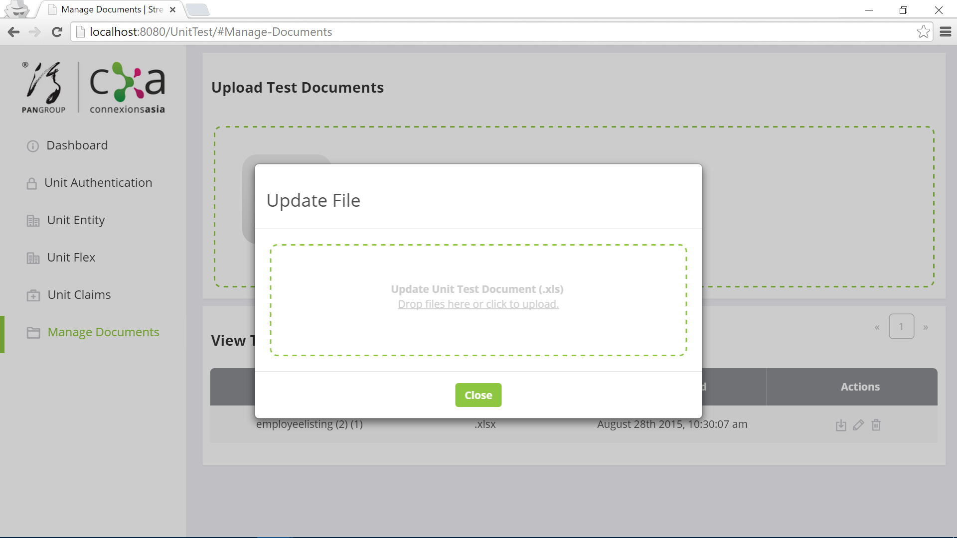

# Running of Firsby.js Test to generate reports

Run this command at node.js - jasmine-node --junitreport test/spec/MainTest_spec.js --output ./gauge/reports/

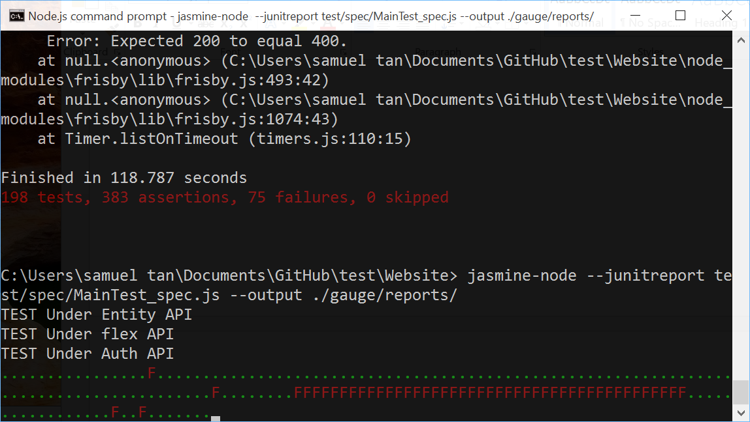

# Using Raml to excel converter

Run this command at node.js – node test/spec/Raml2excel.js